Practicum Case | 
ISYS6123
Introduction to Database Systems
Information Systems | O221-ISYS6123-DD01-09
Valid on Odd Semester Year 2021/2022 | Revision 00

Learning Outcomes
- Query of SQL that suitable with the problem

Topic
- SQL – Data Definition Language (2)

Subtopics
- Create, Alter & Drop View

Tabel Relasional
Relational Table

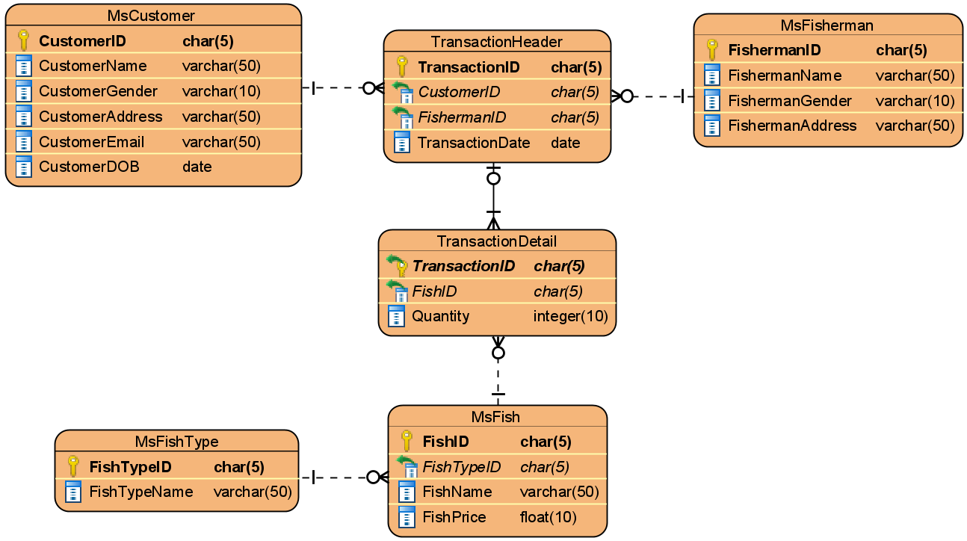

Soal
Case

- Create a view named ‘ViewFemaleCoupon’ to display CustomerName and Coupon (obtained from CustomerID by replacing the first 2 characters with ‘#’) for every female customer whose and born in 2020.
(create view, stuff, year)
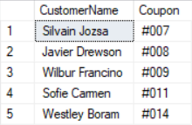

- Create a view named ‘ViewCustomerMembership’ to display Name (obtained from CustomerName), Gender (obtained from CustomerGender), Email (obtained by changing the characters after ‘@’ in CustomerEmail into ‘fmania.com’), Address (obtained from CustomerAddress) for every customer whose address starts with 2 numbers and followed by a space.
(create view, substring, charindex, like)
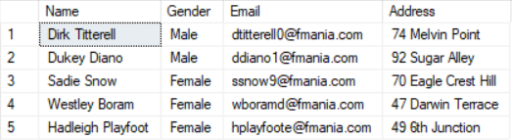

- Create a view named ‘ViewTuna’ to display FishName, FishType (obtained from FishTypeName), and Price (obtained by adding ‘$’ in front of FishPrice) for every fish which type is ‘Tuna’ and price is between 12 and 16.
(create view, cast, between)
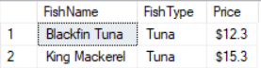

- Create a view named ‘ViewCustomerTransaction’ to display CustomerName and NumberOfTransaction (obtained from the total number of transaction) for every transaction with male customer.
(create view, count)
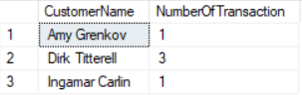

- Create a view named ‘ViewMostExpensiveTransaction’ to display TransactionID, CustomerName, TransactionDate and Money Spent (obtained from the total multiplication of FishPrice and Quantity) for the 3 most expensive transaction. Sort the data in descending format based on the Money Spent.
(create view, top, sum)
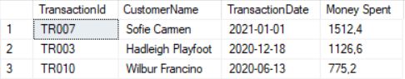

- Create a view named ‘ViewYearlyIncomePerTypeIn2020’ to display Year (obtained from the year of TransactionDate), FishTypeName, and Income (obtained from the total multiplication of FishPrice and Quantity) where the transaction occured in 2020.
(create view, year, sum)
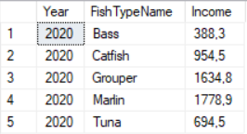

- Create a view named ‘ViewNonGrouperTransaction’ to display CustomerName and NumberOfTransaction (obtained from the total number of transaction) for every transaction which does not contain ‘Grouper’ fish type within the transaction.
(create view, count, not in, subquery)
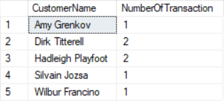

- Create a view named ‘ViewVIPCustomer’ to display CustomerName and MoneySpent (obtained from the total multiplication of FishPrice and Quantity) where the MoneySpent is higher than or equal to AverageMoneySpent (obtained from the average of MoneySpent per customer).
(create view, sum, alias subquery, avg)
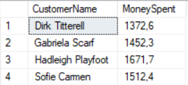

- Create a view named ‘ViewFavoriteFishType’ to display FishTypeName and TotalTransaction (obtained from the total number of transaction) where the TotalTransaction is higher than or equal to AverageNumberOfTransaction (obtained from the average of TotalTransaction per fish type).
(create view, count, alias subquery, avg)
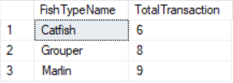

- Delete the view named ‘ViewYearlyIncomePerTypeIn2020’.
(drop view)

